Motion - 05
CLASS 09 - SCIENCE

 | Section A
1 | The path covered from A to C is called: 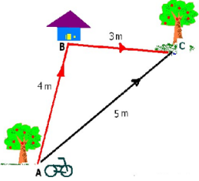  a) Velocity  b) Speed  c) Distance  d) Displacement | [1]
2 | The belowgraph represents 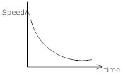  a) constant retardation  b) non – uniform retardation  c) constant acceleration  d) constant velocity | [1]
3 | The given image shows the motion of the moon around the earth. Which of the following statement/s is/are correct regarding the given image? 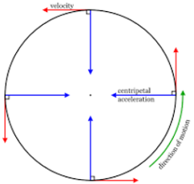  a) The velocity of an object changes  b) All of these  c) The speed of the object remains constant  d) A body moves in a circle | [1]
4 | If the object moves through C and B and reaches A. Then it moves back along the same path and reaches C through B. What is the total path covered? 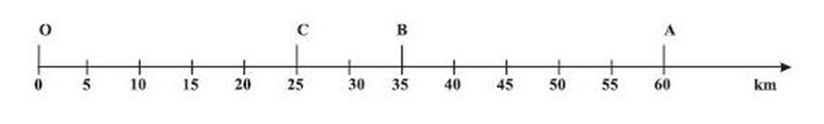  a) 105 Km  b) 95 Km  c) 65 Km  d) 35 Km | [1]
5 | Which of the following is correct about the following distance - time graph? 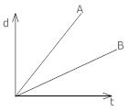  a) speed of A is equal to speed of B  b) None of these.  c) speed of A is greater than speed of B  d) speed of A is less than speed of B | [1]
6 | The displacement of the body after7.5 seconds from the beginning of the motion is 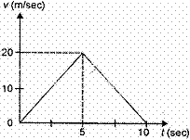  a) 12.5 m  b) 75 m  c) 100 m  d) 87.5 m | [1]
7 | The given image shows a graph of distance travelled against time is a curved line. This graph is meant for: 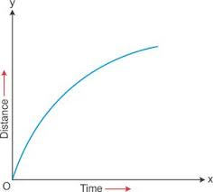  a) Uniform acceleration  b) Uniform speed  c) Non - uniform speed  d) Non - uniform acceleration | [1]
8 | According to the given image of a Distance - Time graph, the speed of a moving body: 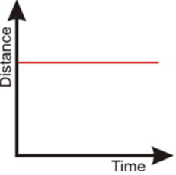  a) Decreases  b) First increases and then decreases  c) Increases  d) Becomes zero | [1]
9 | Four cars A, B, C and D are moving on a levelled road. Their distance - time graph is given as under. The correct statement is: 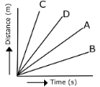  a) Car B is slowest  b) Car C is slowest  c) Car D is faster than Car C  d) Car A is slowest | [1]
10 | From the given v - t graph, it can be inferred that the object is: 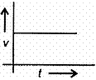  a) in non - uniform motion  b) at rest  c) Non of these  d) in uniform motion | [1]
11 | The v - t graph shown here depicts the motion of A and B such that 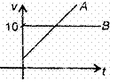  a) they collide when their velocity is 10 ms$​^{−1}$  b) both A and B have zero acceleration  c) both A and B have non - zero acceleration  d) velocity of A exceeds beyond 10 ms$​^{−1}$ | [1]
12 | Which of the Velocity – Time graph shows uniform retardation? 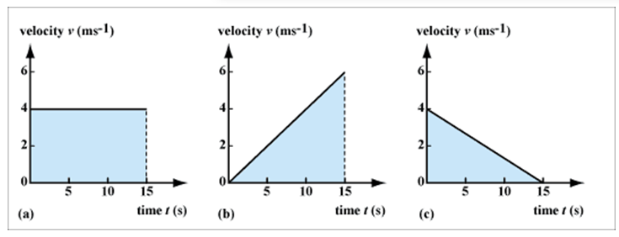  a) b  b) a and b  c) c  d) a | [1]
13 | The given image of Distance – Time graph represents that   a) a body is travelling with non - uniform speed  b) None of these  c) a body stops moving  d) a body is travelling with uniform speed | [1]
14 | If the athlete is running along the shown path ABCDEF, the athlete will have to change his direction six times while he completes one round. He is running on which path? 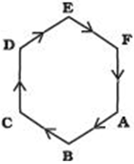  a) Hexagonal path  b) Trigonal path  c) Heptagonal path  d) Pentagonal path | [1]
15 | The graph shown in the image represents: 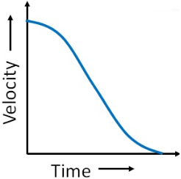  a) Non - uniform retardation  b) Uniform retardation  c) Non - uniform acceleration  d) Uniform acceleration | [1]
16 | Four cars A, B, C and D are moving on the levelled road. Their distance - time graph is given as under. The correct statement is: 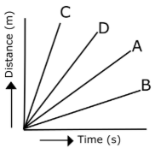  a) Car D is faster than Car C  b) Car A is faster than car D  c) Car Cis slowest  d) Car B is slowest | [1]
17 | The slope of the x - t graph is a measure of 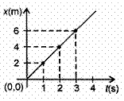  a) velocity = 2ms$​^{−1}$  b) acceleration = 2ms$​^{−2}$  c) acceleration =$\frac{1}{2}$ ms $​^{−2}$  d) velocity =$\frac{1}{2}$ ms $​^{−2}$ | [1]
18 | Match the following with the correct response. 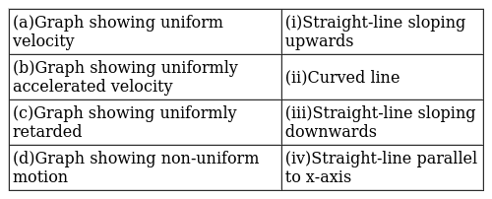  a) (a) - (i), (b) - (iii), (c) - (ii), (d) - (iv)  b) (a) - (iii), (b) - (ii), (c) - (iv), (d) - (i)  c) (a) - (iv), (b) - (i), (c) - (iii), (d) - (ii)  d) (a) - (ii), (b) - (iv), (c) - (i), (d) - (iii) | [1]
19 | Match the following with the correct response : 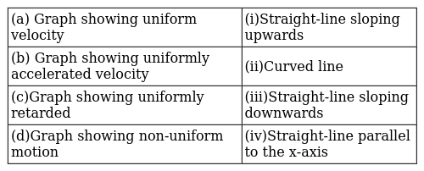  a) (a) - (ii), (b) - (iv),(c) - (i), (d) - (iii)  b) (a) - (i), (b) - (iii),(c) - (ii), (d) - (iv)  c) (a) - (iv), (b) - (i),(c) - (iii), (d) - (ii)  d) (a) - (iii), (b) - (ii),(c) - (iv), (d) - (i) | [1]
20 | Match the following with the correct response. 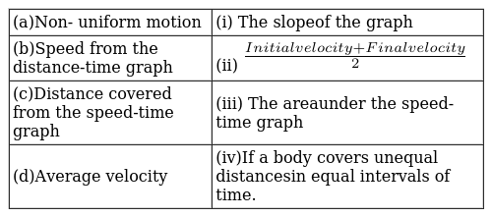  a) (a) - (ii), (b) - (iv), (c) - (i), (d) - (iii)  b) (a) - (iv), (b) - (i), (c) - (iii), (d) - (ii)  c) (a) - (i), (b) - (iii), (c) - (ii), (d) - (iv)  d) (a) - (iii), (b) - (ii), (c) - (iv), (d) - (i) | [1]
21 | Match the following with the correct response. 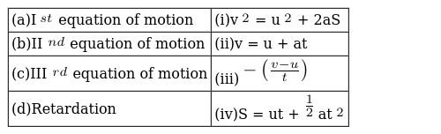  a) (a) - (ii), (b) - (iv), (c) - (i), (d) - (iii)  b) (a) - (i), (b) - (iii), (c) - (ii), (d) - (iv)  c) (a) - (iv), (b) - (i), (c) - (iii), (d) - (ii)  d) (a) - (iii), (b) - (ii), (c) - (iv), (d) - (i) | [1]
22 | Match the following with correct response. 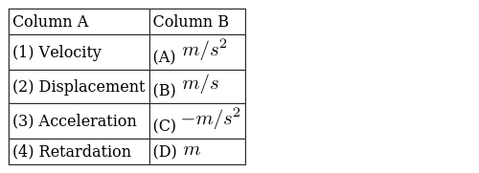  a) 1 - D, 2 - A, 3 - C, 4 - B  b) 1 - B, 2 - D, 3 - A, 4 - C  c) 1 - C, 2 - B, 3 - D, 4 - A  d) 1 - A, 2 - C, 3 - B, 4 - D | [1]
23 | Match the following with the correct response. 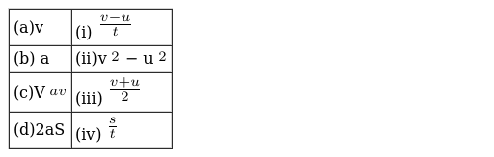  a) (a) - (iii), (b) - (ii), (c) - (iv), (d) - (i)  b) (a) - (ii), (b) - (iv), (c) - (i), (d) - (iii)  c) (a) - (iv), (b) - (i), (c) - (iii), (d) - (ii)  d) (a) - (i), (b) - (iii), (c) - (ii), (d) - (iv) | [1]
24 | Match the following with correct response. 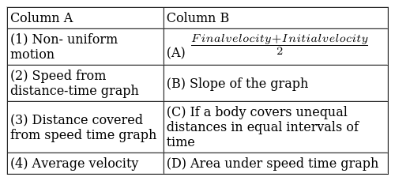  a) 1 - A, 2 - C, 3 - B, 4 - D  b) 1 - D, 2 - A, 3 - C, 4 - B  c) 1 - C, 2 - B, 3 - D, 4 - A  d) 1 - B, 2 - D, 3 - A, 4 - C | [1]
25 | Match the following with correct response. 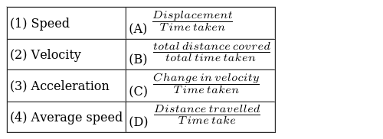  a) 1 - B, 2 - D, 3 - A, 4 - C  b) 1 - D, 2 - A, 3 - C, 4 - B  c) 1 - C, 2 - B, 3 - D, 4 - A  d) 1 - A, 2 - C, 3 - B, 4 - D | [1]
26 | Match the following with correct response. 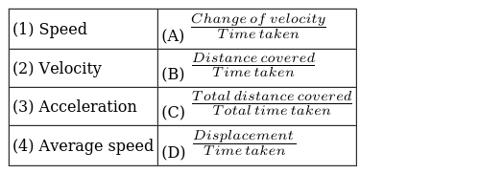  a) 1 - A, 2 - C, 3 - B, 4 - D  b) 1 - C, 2 - B, 3 - D, 4 - A  c) 1 - B, 2 - D, 3 - A, 4 - C  d) 1 - D, 2 - A, 3 - C, 4 - B | [1]
27 | Match the following with the correct response. 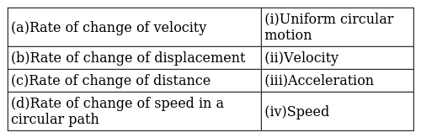  a) (a) - (iv), (b) - (i), (c) - (iii), (d) - (ii)  b) (a) - (i), (b) - (iii), (c) - (ii), (d) - (iv)  c) (a) - (iii), (b) - (ii), (c) - (iv), (d) - (i)  d) (a) - (ii), (b) - (iv), (c) - (i), (d) - (iii) | [1]
28 | Match the following with the correct response : 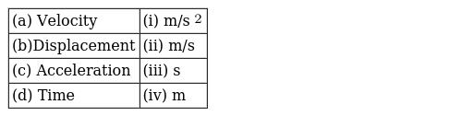  a) (a) - (i), (b) - (iii),(c) - (ii), (d) - (iv)  b) (a) - (ii), (b) - (iv),(c) - (i), (d) - (iii)  c) (a) - (iii), (b) - (ii),(c) - (iv), (d) - (i)  d) (a) - (iv), (b) - (i),(c) - (iii), (d) - (ii) | [1]
29 | Match the following with the correct response : 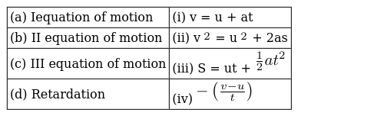  a) (a) - (i), (b) - (iii),(c) - (ii), (d) - (iv)  b) (a) - (iii), (b) - (ii),(c) - (iv), (d) - (i)  c) (a) - (iv), (b) - (i),(c) - (iii), (d) - (ii)  d) (a) - (ii), (b) - (iv),(c) - (i), (d) - (iii) | [1]
30 | Match the following with the correct response. 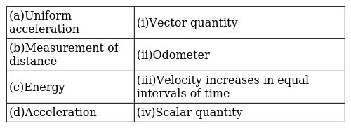  a) (a) - (ii), (b) - (iv), (c) - (i), (d) - (iii)  b) (a) - (iv), (b) - (i), (c) - (iii), (d) - (ii)  c) (a) - (i), (b) - (iii), (c) - (ii), (d) - (iv)  d) (a) - (iii), (b) - (ii), (c) - (iv), (d) - (i) | [1]
31 | Match the following with the correct response : 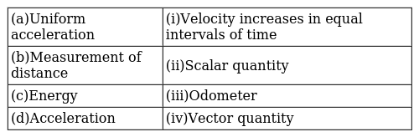  a) (a) - (i), (b) - (iii),(c) - (ii), (d) - (iv)  b) (a) - (iii), (b) - (ii),(c) - (iv), (d) - (i)  c) (a) - (ii), (b) - (iv),(c) - (i), (d) - (iii)  d) (a) - (iv), (b) - (i),(c) - (iii), (d) - (ii) | [1]
32 | Match the following with the correct response : 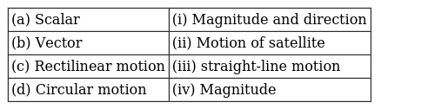  a) (a) - (iii), (b) - (ii),(c) - (iv), (d) - (i)  b) (a) - (ii), (b) - (iv),(c) - (i), (d) - (iii)  c) (a) - (iv), (b) - (i),(c) - (iii), (d) - (ii)  d) (a) - (i), (b) - (iii),(c) - (ii), (d) - (iv) | [1]
33 | Match the following with correct response. 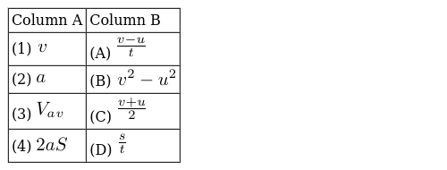  a) 1 - A, 2 - C, 3 - B, 4 - D  b) 1 - C, 2 - B, 3 - D, 4 - A  c) 1 - B, 2 - D, 3 - A, 4 - C  d) 1 - D, 2 - A, 3 - C, 4 - B | [1]
34 | Match the following with the correct response : 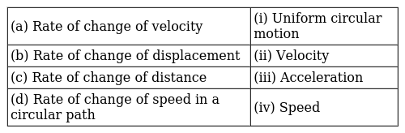  a) (a) - (i), (b) - (iii),(c) - (ii), (d) - (iv)  b) (a) - (iii), (b) - (ii),(c) - (iv), (d) - (i)  c) (a) - (iv), (b) - (i),(c) - (iii), (d) - (ii)  d) (a) - (ii), (b) - (iv),(c) - (i), (d) - (iii) | [1]
35 | Match the following with the correct response. 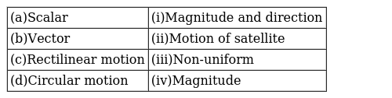  a) (a) - (i), (b) - (iii), (c) - (ii), (d) - (iv)  b) (a) - (iv), (b) - (i), (c) - (iii), (d) - (ii)  c) (a) - (ii), (b) - (iv), (c) - (i), (d) - (iii)  d) (a) - (iii), (b) - (ii), (c) - (iv), (d) - (i) | [1]
36 | Distance can never be ________for a moving body.  a) Positive  b) Negative or zero  c) Zero  d) Negative | [1]
37 | Distance is a ________ quantity.  a) Vector  b) Unit vector  c) Dimensionless  d) Scalar | [1]
38 | The equation of motion is applicable for ________ acceleration motion.  a) Uniformly  b) Non - uniformly  c) Variably  d) Zero | [1]
39 | The maximum displacement between two points in a circular path can be ________. (Radius - r)  a) 2r  b) r  c) $π$ r  d) 2$π$ r | [1]
40 | Statement A: When a body moves with uniform speed, then the average speed is the same as instantaneous speed. Statement B: Average speed is less than the average velocity. Which of the above statement is true?  a) Statement B  b) Neither A nor B  c) Statement A  d) Both Aand B | [1]
41 | Which of the statement is true? Statement A: A curved line in a speed - time graph means non - uniform motion. Statement B: A curved line in a velocity - time graph means uniform acceleration.  a) Statement A is false, B is true  b) Both the statement A and B are true  c) Neither statement A nor Statement B is true.  d) Statement A is true, B is false | [1]
42 | Statement A: Uniform circular motion is a case of accelerated motion. Statement B: In the third equation of motion we do not have the time. Which of the following statements are correct:  a) Neither statement A nor statement B is true.  b) Statement B is true, A is false  c) Both statements A and B are true  d) Statement A is true, B is false | [1]

